Press release
EMBARGOED TO 19:00hrs 19 June 2025
Women in Art Fair prize-winners announced

19-21 June at gallery@oxo

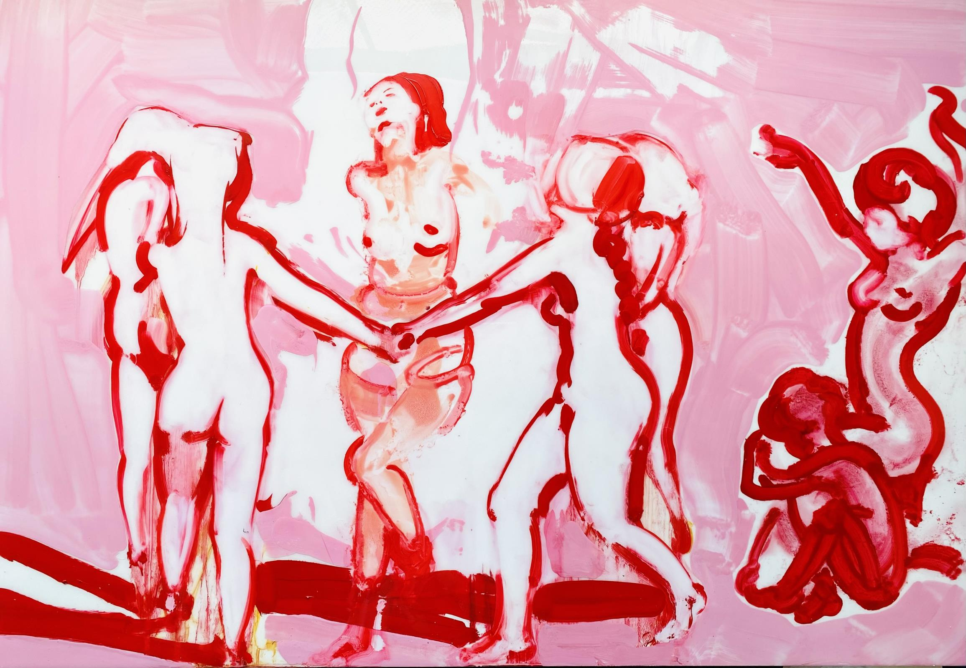
Ilona Salzay, Ritual, 2023, oil and resin on wood board, 70 x 100 cm

London, 19 June 2025
Women in Art Fair this evening announced the winners of their inaugural Women in Art Fair Prize.

Approximately two thousand art works from over 600 Open Call applicants were whittled down to 100 stand out pieces for this year’s Women in Art Fair. Each exhibitor was automatically entered for the prize. A 1st prize of £1500, sponsored by Fladgate, a 2nd prize of £750 and 3rd prize of £400 were awarded to the artists that the selection committee believe most deserve financial support for their ongoing practice.

First prize went to Beirut-born, British artist Ilona Szalay. Her poetic paintings portray what she describes as an ‘alternative reality’, where women play a more empowered and liberated role than she finds in today’s world. The fluid, looping lines of her brushstrokes, in lipstick red and pink in the selection of paintings on show at Women in Art Fair, portray a space that hovers between fantasy and reality, dominance and submission.

First prize sponsor law firm Fladgate’s Partner Hetty Gleave, who specialises in art and cultural property law, says, “To us, Ilona’s dream of a more empowered space for women isn’t that far away! Fladgate’s gender group works across the firm to ensure equal opportunities at every level; we are signatories to the Women in the Law pledge and we also run a ‘Male Champions for Change’ programme that encourages men to join the gender conversation. Partnering with Women in Art Fair makes enormous sense, given our ongoing commitment to gender equality.”

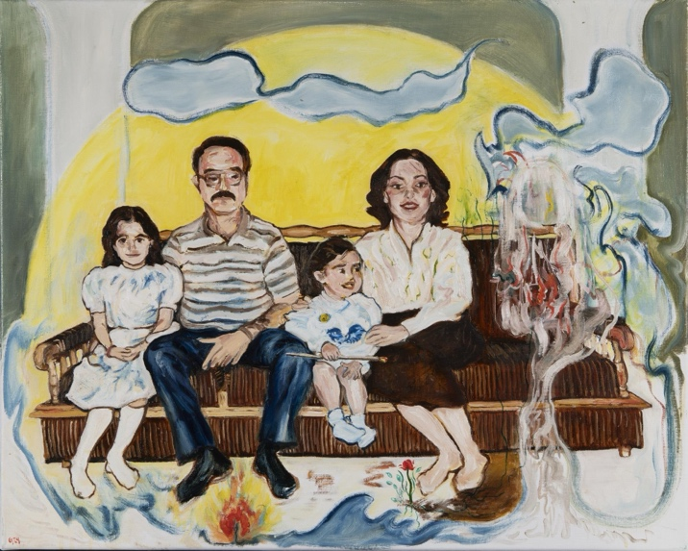
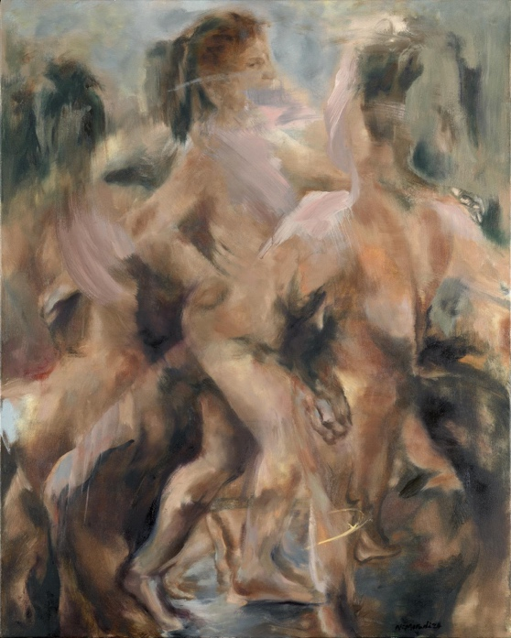
Golnaz Jebelli, Seeing the Extraordinary in the Mundane, oil on canvas; Nazanin Moradi, Whispers of Graces, oil on canvas, 100 x 80 cm

Second prize was awarded to Golnaz Jebelli for her intriguing painting Seeing the Extraordinary in the Mundane. Indian born to Persian parents, Golnaz cites the influence of Eastern wisdom and the works of Carl Jung on Archetypes and the Shadow. Her portraits are a way of depicting the inner child, a psychological storytelling. She says, “In the original photo which inspired this painting I am (the youngest child) looking intensely at something. What looks like an empty space on the sofa was filled by a spirit. I let the lines and brushstrokes flow out, like a stream of consciousness - in other words like automatic painting.” The painting was shortlisted by The College of Psychic Studies for the art competition: Inspiration from the Elements 2024.

Third prize went to Iranian-British artist Nazanin Moradi for her figurative paintings that explore the female body as a vessel of transformation, suspended in motion past and future, dream and reality, self and higher self. A multi-disciplinary artist who works across performance, painting and digital art, she says, “I am interested in bridging the gap between the inner and outer dimensions …. to bring the intangible into tangible form.”

For further information please contact Theresa at Theresa Simon & Partners
07976 766221 theresa@theresasimon.com

Editors notes

Women in Art Fair
Women in Art Fair is dedicated to redressing the gender imbalance in the art industry. Founded in 2023, WIAF ’s mission is to create a positive global platform from which female artists, curators and gallerists are given an opportunity to show their work and contribute to the developing exchange of ideas around gender, sexuality and culture.

Women in Art Fair selection committee
Women in Art Fair is extremely grateful to its selection committee, which narrowed down the Open Call entrants from 600 to 60 and chose the three prize-winners. The committee comprised:
- Alison Mosshart, celebrated musician, artist, and frontwoman of The Kills and The Dead Weather
- Artist Vanessa Raw
- Curator, art dealer and cultural strategist Virginia Damtsa.

Women in Art Fair
19-21 June
gallery@oxo , Oxo Tower Wharf, Barge House St, London SE1 9PH
www.womeninartfair.com | @womeninartfairofficial
Opening Hours
Thursday 19 June: 11am – 6pm
Friday 20 June: 11am – 6pm
Saturday 21 June: 11am – 6pm

